Common Rate Limiting Strategies - Leaky Bucket

🚦 What is Leaky Bucket
# Source: AI Source: Provided by: [Data Path: Persons Table -> ID Column: 1, Name_En Column: Motasem Essam] -> From: [ChatGPT] on [1/19/2026]
Leaky Bucket is a rate limiting strategy that processes requests at a constant, fixed rate, regardless of how fast they arrive.
👉 Think of it like a bucket with a small hole:
water (requests) enters fast, but leaks out at a steady speed.

🔑 How It Works
# Source: AI Source: Provided by: [Data Path: Persons Table -> ID Column: 1, Name_En Column: Motasem Essam] -> From: [ChatGPT] on [1/19/2026]
- Requests enter a queue (bucket)
- The system processes requests at a fixed rate
- If the bucket is full → ❌ new requests are rejected
- Output is always smooth and constant

🧱 Example
# Source: AI Source: Provided by: [Data Path: Persons Table -> ID Column: 1, Name_En Column: Motasem Essam] -> From: [ChatGPT] on [1/19/2026]
Rule
Queue size = 5 requests
Processing rate = 1 request per second

Scenario 1️⃣ – Normal Flow
# Source: AI Source: Provided by: [Data Path: Persons Table -> ID Column: 1, Name_En Column: Motasem Essam] -> From: [ChatGPT] on [1/19/2026]
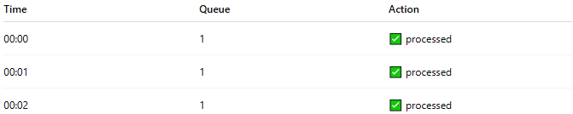
Time | Queue | Action
00:00 | 1 | ✅ processed
00:01 | 1 | ✅ processed
00:02 | 1 | ✅ processed
👉 Smooth, steady flow

Scenario 2️⃣ – Burst Incoming
# Source: AI Source: Provided by: [Data Path: Persons Table -> ID Column: 1, Name_En Column: Motasem Essam] -> From: [ChatGPT] on [1/19/2026]
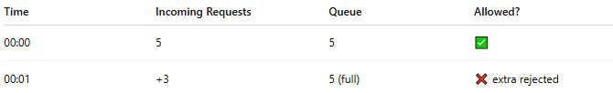
Time | Incoming Requests | Queue | Allowed?
00:00 | 5 | 5 | ✅
00:01 | +3 | 5 (full) | ❌ extra rejected
👉 Requests arrive fast, but:
- Only queue capacity is stored
- Extra requests are dropped

Scenario 3️⃣ – Processing Over Time
# Source: AI Source: Provided by: [Data Path: Persons Table -> ID Column: 1, Name_En Column: Motasem Essam] -> From: [ChatGPT] on [1/19/2026]
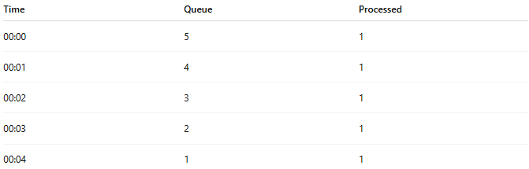
Time | Queue | Processed
00:00 | 5 | 1
00:01 | 4 | 1
00:02 | 3 | 1
00:03 | 2 | 1
00:04 | 1 | 1
👉 Output is constant and predictable

🧩 Simple Implementation Idea
# Source: AI Source: Provided by: [Data Path: Persons Table -> ID Column: 1, Name_En Column: Motasem Essam] -> From: [ChatGPT] on [1/19/2026]
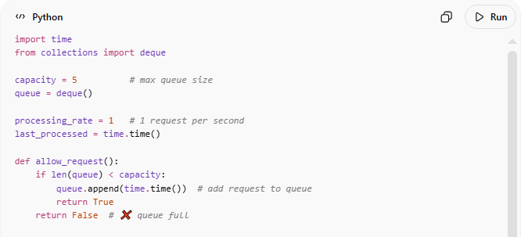
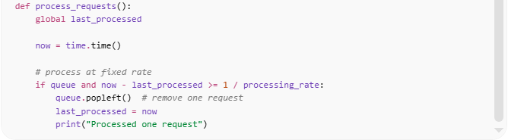
import time
from collections import deque

capacity = 5 # max queue size
queue = deque()

processing_rate = 1 # 1 request per second
last_processed = time.time()

def allow_request():
if len(queue) < capacity:
queue.append(time.time()) # add request to queue
return True
return False # ❌ queue full

def process_requests():
global last_processed

now = time.time()

# process at fixed rate
if queue and now - last_processed >= 1 / processing_rate:
queue.popleft() # remove one request
last_processed = now
print("Processed one request")

Code Description

Part 1
# Source: AI Source: Provided by: [Data Path: Persons Table -> ID Column: 1, Name_En Column: Motasem Essam] -> From: [ChatGPT] on [1/19/2026]
Variables
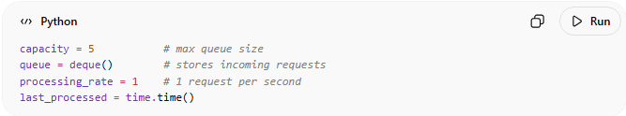
capacity = 5 # max queue size
queue = deque() # stores incoming requests
processing_rate = 1 # 1 request per second
last_processed = time.time()
Idea:
- Think of a bucket with a hole at the bottom.
- Requests go into the bucket (queue).
- The bucket leaks at a fixed rate (processing_rate).
- If the bucket is full → ❌ reject request.

Part 2
# Source: AI Source: Provided by: [Data Path: Persons Table -> ID Column: 1, Name_En Column: Motasem Essam] -> From: [ChatGPT] on [1/19/2026]
allow_request()
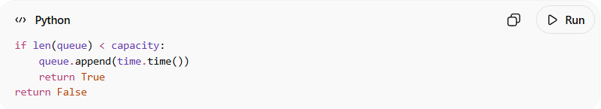
if len(queue) < capacity:
queue.append(time.time())
return True
return False
- Checks if there is space in the queue (bucket).
- ✅ If yes → adds request and allows it.
- ❌ If full → rejects request (prevents burst overflow).

Part 3
# Source: AI Source: Provided by: [Data Path: Persons Table -> ID Column: 1, Name_En Column: Motasem Essam] -> From: [ChatGPT] on [1/19/2026]
process_requests()
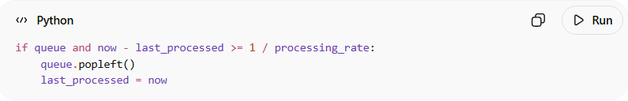
if queue and now - last_processed >= 1 / processing_rate:
queue.popleft()
last_processed = now
- Processes 1 request per second (fixed rate).
- Removes it from the queue (bucket leaks).
- Even if many requests arrive at once, they are processed slowly.

📊 Full Scenario Table (All Number Cases)

Initial State
# Source: AI Source: Provided by: [Data Path: Persons Table -> ID Column: 1, Name_En Column: Motasem Essam] -> From: [ChatGPT] on [1/19/2026]
- capacity = 5
- processing_rate = 1/sec
- queue = []

Scenario 1: Burst of 6 requests immediately
# Source: AI Source: Provided by: [Data Path: Persons Table -> ID Column: 1, Name_En Column: Motasem Essam] -> From: [ChatGPT] on [1/19/2026]
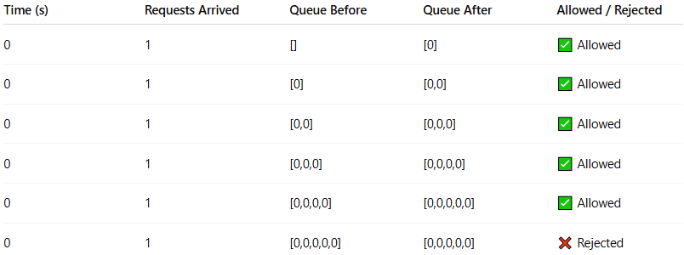
Time (s) | Requests Arrived | Queue Before | Queue After | Allowed / Rejected
0 | 1 | [] | [0] | ✅ Allowed
0 | 1 | [0] | [0,0] | ✅ Allowed
0 | 1 | [0,0] | [0,0,0] | ✅ Allowed
0 | 1 | [0,0,0] | [0,0,0,0] | ✅ Allowed
0 | 1 | [0,0,0,0] | [0,0,0,0,0] | ✅ Allowed
0 | 1 | [0,0,0,0,0] | [0,0,0,0,0] | ❌ Rejected
✅ Observation:
- Only 5 requests allowed (bucket capacity).
- 6th request rejected → prevents burst overflow.

Scenario 2: Processing over time
# Source: AI Source: Provided by: [Data Path: Persons Table -> ID Column: 1, Name_En Column: Motasem Essam] -> From: [ChatGPT] on [1/19/2026]
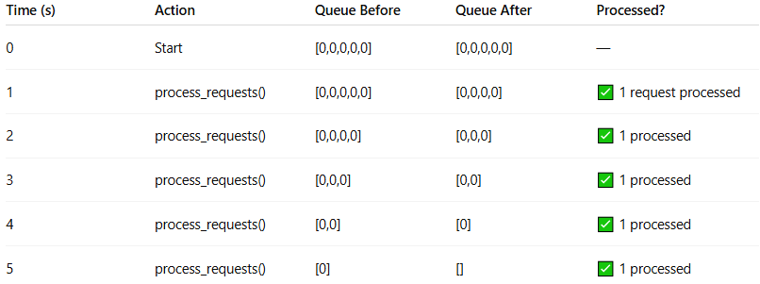
Time (s) | Action | Queue Before | Queue After | Processed?
0 | Start | [0,0,0,0,0] | [0,0,0,0,0] | —
1 | process_requests() | [0,0,0,0,0] | [0,0,0,0] | ✅ 1 request processed
2 | process_requests() | [0,0,0,0] | [0,0,0] | ✅ 1 processed
3 | process_requests() | [0,0,0] | [0,0] | ✅ 1 processed
4 | process_requests() | [0,0] | [0] | ✅ 1 processed
5 | process_requests() | [0] | [] | ✅ 1 processed
- Requests are processed 1 per second, smoothing out the burst.

Scenario 3: Mixed Arrival + Processing
# Source: AI Source: Provided by: [Data Path: Persons Table -> ID Column: 1, Name_En Column: Motasem Essam] -> From: [ChatGPT] on [1/19/2026]
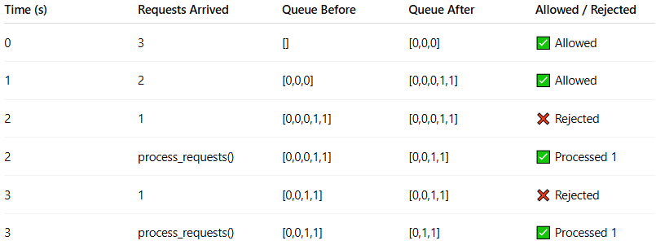
Time (s) | Requests Arrived | Queue Before | Queue After | Allowed / Rejected
0 | 3 | [] | [0,0,0] | ✅ Allowed
1 | 2 | [0,0,0] | [0,0,0,1,1] | ✅ Allowed
2 | 1 | [0,0,0,1,1] | [0,0,0,1,1] | ❌ Rejected
2 | process_requests() | [0,0,0,1,1] | [0,0,1,1] | ✅ Processed 1
3 | 1 | [0,0,1,1] | [0,0,1,1] | ❌ Rejected
3 | process_requests() | [0,0,1,1] | [0,1,1] | ✅ Processed 1

🚀 How This Prevents Burst
# Source: AI Source: Provided by: [Data Path: Persons Table -> ID Column: 1, Name_En Column: Motasem Essam] -> From: [ChatGPT] on [1/19/2026]
- Queue limit (capacity) ensures you cannot accept more requests than allowed → prevents burst overflow.
- Fixed processing rate (processing_rate) ensures requests are handled smoothly over time, even if many requests arrive at once.
- Unlike sliding window or token bucket, Leaky Bucket processes requests at a constant rate → no sudden spikes downstream.
✅ Key Insights
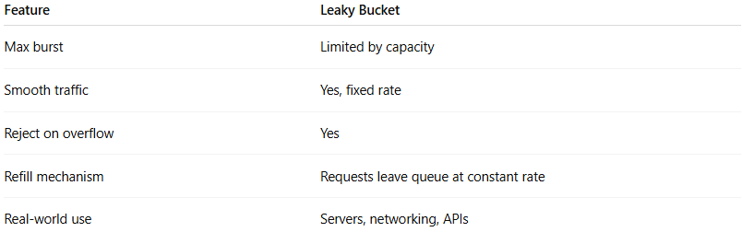
Feature | Leaky Bucket
Max burst | Limited by capacity
Smooth traffic | Yes, fixed rate
Reject on overflow | Yes
Refill mechanism | Requests leave queue at constant rate
Real-world use | Servers, networking, APIs

🔄 Key Behavior
# Source: AI Source: Provided by: [Data Path: Persons Table -> ID Column: 1, Name_En Column: Motasem Essam] -> From: [ChatGPT] on [1/19/2026]
- Input can be bursty ⚡
- Output is always smooth ➖
- No sudden spikes allowed

⚖️ Leaky Bucket vs Token Bucket
# Source: AI Source: Provided by: [Data Path: Persons Table -> ID Column: 1, Name_En Column: Motasem Essam] -> From: [ChatGPT] on [1/19/2026]
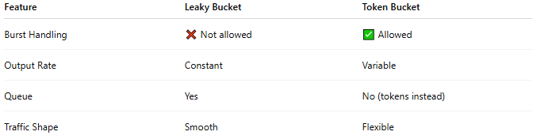
Feature | Leaky Bucket | Token Bucket
Burst Handling | ❌ Not allowed | ✅ Allowed
Output Rate | Constant | Variable
Queue | Yes | No (tokens instead)
Traffic Shape | Smooth | Flexible

✅ Advantages
# Source: AI Source: Provided by: [Data Path: Persons Table -> ID Column: 1, Name_En Column: Motasem Essam] -> From: [ChatGPT] on [1/19/2026]
- Ensures stable and constant traffic
- Protects backend systems from spikes
- Simple and predictable behavior

❌ Disadvantages
# Source: AI Source: Provided by: [Data Path: Persons Table -> ID Column: 1, Name_En Column: Motasem Essam] -> From: [ChatGPT] on [1/19/2026]
- Drops excess requests during bursts
- Less flexible than Token Bucket
- May delay or reject valid traffic

🧾 Summary
# Source: AI Source: Provided by: [Data Path: Persons Table -> ID Column: 1, Name_En Column: Motasem Essam] -> From: [ChatGPT] on [1/19/2026]
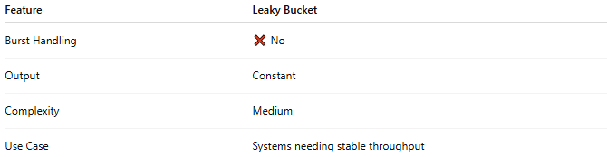
Feature | Leaky Bucket
Burst Handling | ❌ No
Output | Constant
Complexity | Medium
Use Case | Systems needing stable throughput
Leaky Bucket smooths traffic by forcing requests to be processed at a constant rate, even if they arrive in bursts.

